ASIC Implementation Testing and Timing Study

1. Objective
As an extension of the FPGA-based evaluation, the finalized 16×16 pipelined Wallace Tree multiplier with a Kogge–Stone final adder was evaluated using ASIC-oriented implementation flows.
The purpose of this study was to examine:
- ASIC synthesis and physical implementation behavior
- Timing under different PVT corners
- The influence of interconnect/wire selection on timing
- Area requirements
- Critical-path identification
- The effect of changing pipeline-register placement
- Behavior in both SKY130 and ASAP7 technology environments
The experiment was primarily intended as an architectural and implementation study rather than a production-ready ASIC tapeout.

2. SKY130 Implementation
The 16×16 pipelined Wallace multiplier with a Kogge–Stone final adder was implemented using the SKY130 technology environment.
Unlike the FPGA evaluation, the ASIC implementation showed that timing is influenced not only by the logic itself but also by the characteristics of the physical interconnect.
Three wire-selection conditions were evaluated:
- Worst wires
- Typical wires
- Best wires
The results were evaluated at Fast, Typical, and Slow PVT corners.

3. SKY130 Timing Results
3.1 Worst-Wire Condition
Under the worst-wire condition, the reported frequencies were:

PVT Corner | Frequency
Typical | 653.72 MHz
Slow | 307.51 MHz
Fast | 1.20919 GHz
The results demonstrate that pessimistic interconnect conditions can significantly reduce the achievable operating frequency.

3.2 Typical-Wire Condition
Under the typical-wire condition:
PVT Corner | Frequency
Typical | 704.87 MHz
Slow | 321.73 MHz
Fast | 1.31996 GHz
Compared with the worst-wire condition, the Typical corner improved from 653.72 MHz to 704.87 MHz.

3.3 Best-Wire Condition
Under the best-wire condition:
PVT Corner | Frequency
Typical | 753.00 MHz
Slow | 326.87 MHz
Fast | 1.43823 GHz
The highest reported result was therefore:
1.43823 GHz at the Fast PVT corner.
At the Typical corner, the design achieved:
753.00 MHz
while the Slow corner achieved:
326.87 MHz.

4. Effect of Wire Conditions
The SKY130 results provide an important physical-design observation.
For the same logical architecture, changing the assumed wire condition produced a noticeable change in timing.
At the Typical PVT corner:
- Worst wires: 653.72 MHz
- Typical wires: 704.87 MHz
- Best wires: 753.00 MHz
At the Fast corner:
- Worst wires: 1.209 GHz
- Typical wires: 1.320 GHz
- Best wires: 1.438 GHz
This demonstrates that the performance of a high-speed arithmetic architecture cannot be determined solely from its RTL logic depth.
Physical interconnect characteristics can become an important component of the total critical-path delay.
The Slow corner remained the limiting operating condition, with frequencies of approximately:
307.51–326.87 MHz
across the three wire conditions.

5. SKY130 Summary

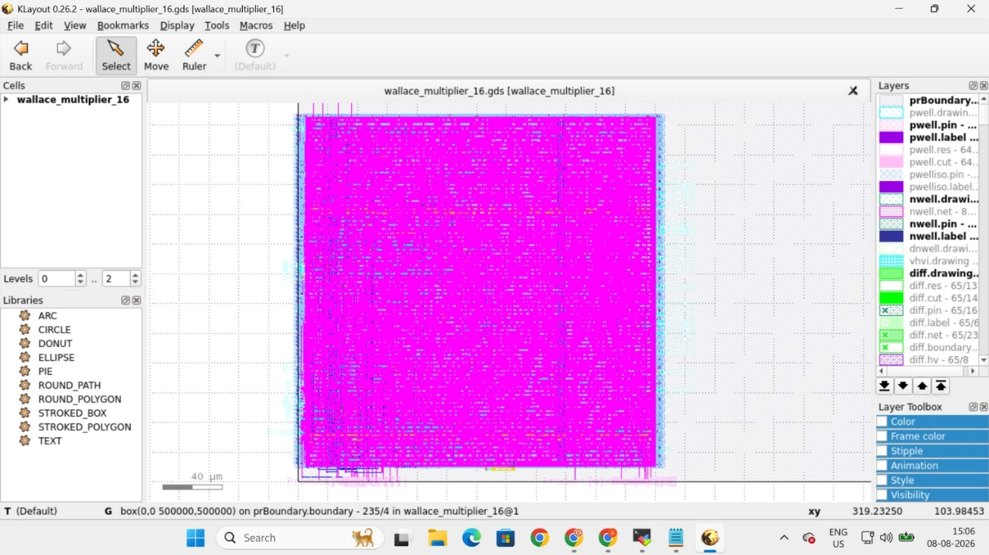

Wire Condition | Typical | Slow | Fast
Worst | 653.72 MHz | 307.51 MHz | 1.209 GHz
Typical | 704.87 MHz | 321.73 MHz | 1.320 GHz
Best | 753.00 MHz | 326.87 MHz | 1.438 GHz
The results show both PVT dependence and interconnect dependence.
Therefore, the 1.438 GHz result should be interpreted specifically as the reported result under the corresponding Fast PVT and best-wire implementation condition, rather than as a universal operating frequency for the multiplier.

6. ASAP7 Implementation
The same general architecture was also evaluated using an ASAP7 technology environment.
The initial implementation produced:
Area: 368 µm²
Reported Fmax: 4.27 GHz
The timing target for this experiment was:
5 GHz
Therefore, the initial implementation did not meet the 5 GHz target.
The identified critical path was through the:
Kogge–Stone final adder
with a reported critical-path delay of:
233.99 ps
This result was particularly useful because it showed that, after the Wallace reduction tree, the final carry-propagation stage remained a significant timing constraint.

7. Pipeline Placement Experiment
Following the initial ASAP7 implementation, the pipeline-register placement was modified.
The revised pipeline structure was:
Input Register → Stage 1 → Stage 3 → Stage 5 → Kogge–Stone Level 1 → Output Register
This changed the distribution of combinational work between pipeline boundaries.
The revised implementation produced:
Area: 470 µm²
with approximately:
84% utilization
The reported maximum operating frequency increased to:
5.28 GHz
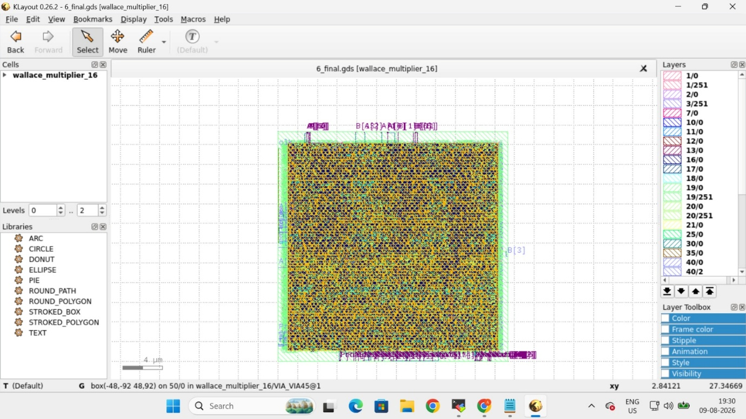

8. Effect of Pipeline Modification
The change in pipeline placement produced a significant timing improvement:
Configuration | Area | Fmax
Initial ASAP7 implementation | 368 µm² | 4.27 GHz
Revised pipeline placement | 470 µm² | 5.28 GHz
The frequency increased from:
4.27 GHz → 5.28 GHz
while area increased from:
368 µm² → 470 µm²
This illustrates a fundamental hardware-design trade-off.
Additional or differently positioned pipeline boundaries can reduce the amount of combinational work contained within a single clock period. This can increase the achievable operating frequency, but the additional storage and physical resources increase area.
The revised implementation therefore demonstrates that pipeline placement is an architectural parameter, rather than simply a matter of adding more registers indiscriminately.

9. Important Architectural Observation
The ASAP7 experiment also reinforced an observation made during the earlier FPGA experiments.
Increasing pipeline depth does not automatically guarantee a proportional increase in frequency.
What matters is how the pipeline boundaries divide the actual critical paths.
In the initial implementation, the Kogge–Stone final adder was identified as the critical path. Consequently, modifying the pipeline placement around the arithmetic stages was able to redistribute the timing burden and allow the design to achieve the 5 GHz target.
The revised implementation reached:
5.28 GHz
demonstrating that an appropriate pipeline distribution can be more important than simply increasing the total number of registers.

10. Overall ASIC Observations
The ASIC implementation experiments provided several important conclusions.
1. PVT conditions matter
The same architecture produced substantially different operating frequencies under Fast, Typical, and Slow conditions.
2. Interconnect matters
The SKY130 results showed measurable differences between worst-, typical-, and best-wire conditions.
3. The critical path can move between architectural blocks
The Kogge–Stone adder became the dominant timing constraint in the ASAP7 implementation.
4. Pipeline placement matters
The ASAP7 experiment demonstrated that changing the locations of pipeline boundaries can substantially improve timing.
5. Performance comes with an area cost
The revised ASAP7 implementation increased area from 368 µm² to 470 µm², while improving Fmax from 4.27 GHz to 5.28 GHz.
6. FPGA and ASIC results should not be directly equated
The FPGA implementation and ASIC implementation use fundamentally different physical resources and timing characteristics. Therefore, their absolute frequency values should be treated as separate implementation-specific measurements.

11. Conclusion
The ASIC implementation study successfully extended the multiplier evaluation beyond FPGA technology.
In SKY130, the 16×16 pipelined Wallace/Kogge–Stone multiplier achieved frequencies ranging from approximately 307.51 MHz to 1.438 GHz, depending on PVT corner and wire condition.
In ASAP7, the initial implementation achieved 4.27 GHz with an area of 368 µm², with the Kogge–Stone adder identified as the critical path.
After modifying the pipeline placement, the implementation achieved 5.28 GHz at an area of 470 µm², with approximately 84% utilization.
The study therefore demonstrated the importance of considering not only arithmetic architecture, but also physical interconnect, PVT conditions, critical-path structure, and pipeline placement when evaluating high-speed ASIC designs.

